AI-Augmented Backend Development
Project :
TITLE : AI WeatherWise – Intelligent Weather Platform with Google Gemini AI Insights

Project Description
AI WeatherWise is an AI-Augmented backend Web Application developed using the MERN stack (MongoDB, Express.js, Node.js, with a React frontend) integrated with Artificial Intelligence capabilities powered by Large Language Models (Google Gemini). The system enables users to interact with weather data through natural language, receive AI-generated weather summaries, get personalised clothing, travel, activity and severe-weather recommendations, and ask free-form questions to a conversational weather assistant. By combining traditional backend development (JWT authentication, role-based access control, REST APIs, caching and monitoring) with modern AI technology, and by adding a zerodowntime fallback engine that keeps every endpoint working even when an external API fails, the platform delivers an intelligent, scalable and user-friendly experience that improves decision-making, accessibility and operational reliability.

Scenario
Paragraph 1 – Problem: Weather applications and portals present large volumes of raw numbers: temperature, humidity, wind speed, atmospheric pressure, UV index and Air Quality Index (AQI). The user must interpret these discordant metrics on their own to decide simple things such as what to wear, whether it is safe to commute, or when to exercise outdoors. A parent dressing a child, a commuter planning the day, or a field supervisor scheduling outdoor work all face the same problem: cold tables and charts do not tell them what to do. Traditional systems also depend on hard-coded rules (for example, "if temperature > 35 °C then show Hot") and on third-party weather APIs; when those APIs are down, rate-limited or unconfigured, the application simply fails.
Paragraph 2 – AI Solution: AI WeatherWise solves this by placing an AI layer inside the backend. Live weather metrics and 7-day forecasts are passed to Google Gemini, which converts them into a short natural-language summary and structured recommendations across four areas: Clothing & Wardrobe, Travel Precautions (Favorable / Caution / Hazardous), Activity Windows (best outdoor time and indoor alternatives) and Severe Weather Risk (risk level, headline and emergency instructions). An Interactive Weather Assistant answers custom questions such as "Can I cycle to work at 5 PM?". Since rigid rules cannot weigh wind, UV, pollution and personal activity together, AI reasoning is essential. To protect availability, a smart-fallback engine generates deterministic, physically plausible weather and rule-based insights whenever the weather API or Gemini key is missing, times out or returns HTTP 429, and a NodeCache layer prevents quota exhaustion.
Paragraph 3 – Impact: Everyday users gain clear, personalised advice instead of raw numbers; they can save favourite cities, review their search history and export it as CSV/JSON. Administrators gain a governance console with API telemetry (latency, endpoint hits, status codes, fallback rate), user management (promote, demote, suspend, delete) and a broadcastnotification system. Because the service never goes offline, students, commuters, outdoor workers and small organisations receive dependable, easy-to-understand weather intelligence.
AI capabilities used in this project:
- AI Chatbot – Interactive Weather Assistant (conversational Q&A via POST /api/ai/ask)
- Content Generation – Natural-language weather summaries generated from live metrics
- Question Answering – Answers to user questions about travel and outdoor activities
- Intelligent Recommendations – Clothing, travel, activity and severe-weather advisories
- AI-powered Insights – Cross-metric risk assessment and severe-weather alerts
- Not implemented – Semantic Search, Vector Search and Document Analysis are NOT implemented in the current repository (see Mandatory Functionalities table and Future Enhancements).
System Requirements :
To ensure smooth development, deployment, and usage of the AI WeatherWise AI-Augmented Backend Application, the following system prerequisites must be met.

1. Software Requirements

Operating System
- Windows 10/11
- macOS
- Linux
Node.js (v18 or above)
Provides the runtime environment for the backend (Express) and for the Vite/React frontend.

npm (v8 or above)
Package manager used for dependency installation and running scripts (npm start, npm run dev, npm test).
Express.js
Backend framework used for REST API development, routing and middleware chains.

MongoDB Community Server / MongoDB Atlas
NoSQL database used to store:
- User accounts and roles
- Favourite locations
- AI insights (summaries and recommendations)
- Weather search history
- Notifications and user settings
- API telemetry logs
If no MONGO_URI is supplied, the backend automatically starts an embedded in-memory MongoDB for zero-configuration development.

MongoDB Atlas Search / Atlas Vector Search
Not used in the current repository. Planned as a future enhancement for document search and semantic retrieval.

AI Service Provider
- Google Gemini API (primary, used by geminiService.js)
- OpenWeatherMap API (weather data source; optional, simulation fallback available)

AI SDK
Google Gemini SDK, called from the service layer (services/geminiService.js) with structured prompts and a smart-fallback engine. LangChain is not used.

Other libraries
mongoose, jsonwebtoken, bcryptjs, helmet, morgan, express-rate-limit, express-validator, nodecache, cors, dotenv; frontend: React, Vite, Axios, Chart.js, React Router.

Browser
- Google Chrome
- Mozilla Firefox
Postman
API testing
Visual Studio Code
Development environment
Git & GitHub
Version control (https://github.com/Harish-stackai/weatherwise)

2. Hardware Requirements
Processor
Intel Core i5 (8th Gen+) / AMD Ryzen 5+
RAM
Minimum 8 GB. Recommended 16 GB
Storage
Minimum 5 GB Free Space
Internet Connection
Required for Gemini and weather API communication (the fallback engine works offline)
Display
1366 × 768 or above

Project Architecture
Technical Architecture :
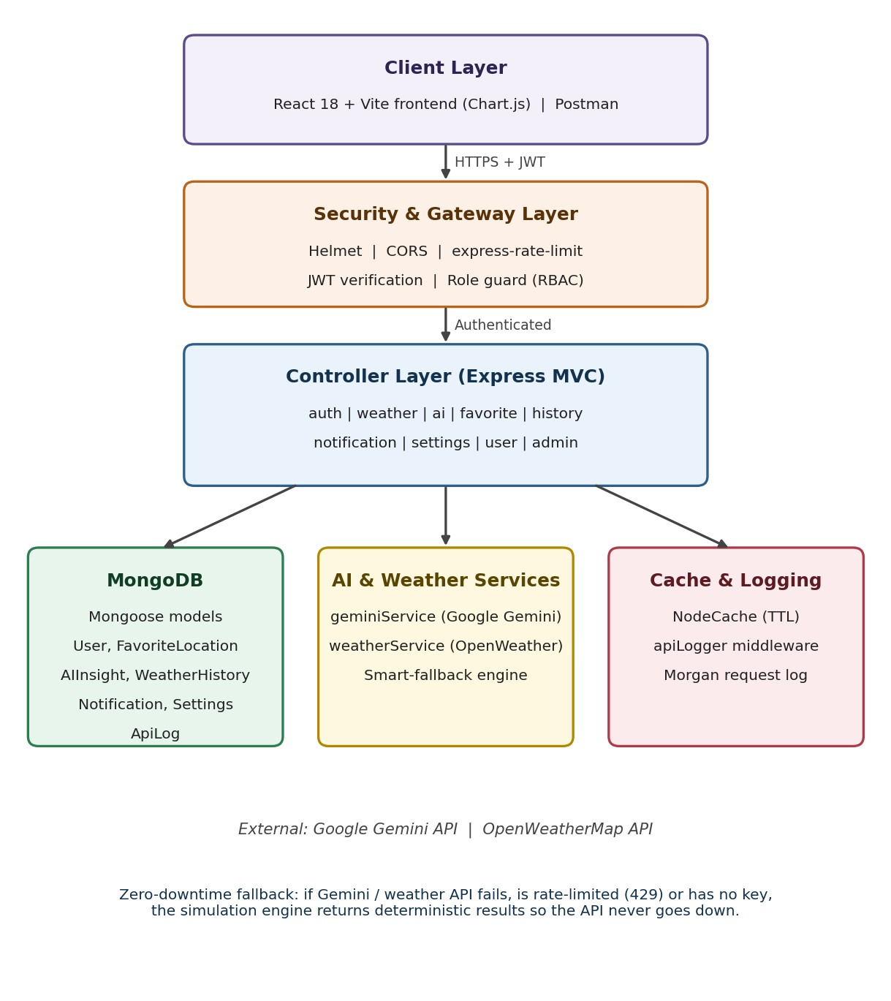
Figure 1: AI WeatherWise technical architecture

Backend Layer
- Node.js
- Express.js
- JWT Authentication
- REST APIs (auth, weather, ai, favorites/locations, history, admin)

Database Layer
- MongoDB with Mongoose ODM
- Embedded in-memory MongoDB fallback for development
- (Atlas Search / Vector Search – planned, not yet implemented)

AI Layer
- Google Gemini LLM via geminiService.js
- Prompt engineering for structured JSON insights
- Smart-fallback engine when the LLM is unavailable
- (RAG pipeline and embedding models – planned, not yet implemented)

Storage & Caching Layer
- MongoDB Collections
- NodeCache with TTL to prevent repeated external API calls

Security Layer
- JWT Authentication (stateless) and bcrypt hashing
- Protected Routes and Role-Based Access Control (role.js)
- Input Validation (express-validator)
- Helmet headers, CORS and express-rate-limit

ER Diagram
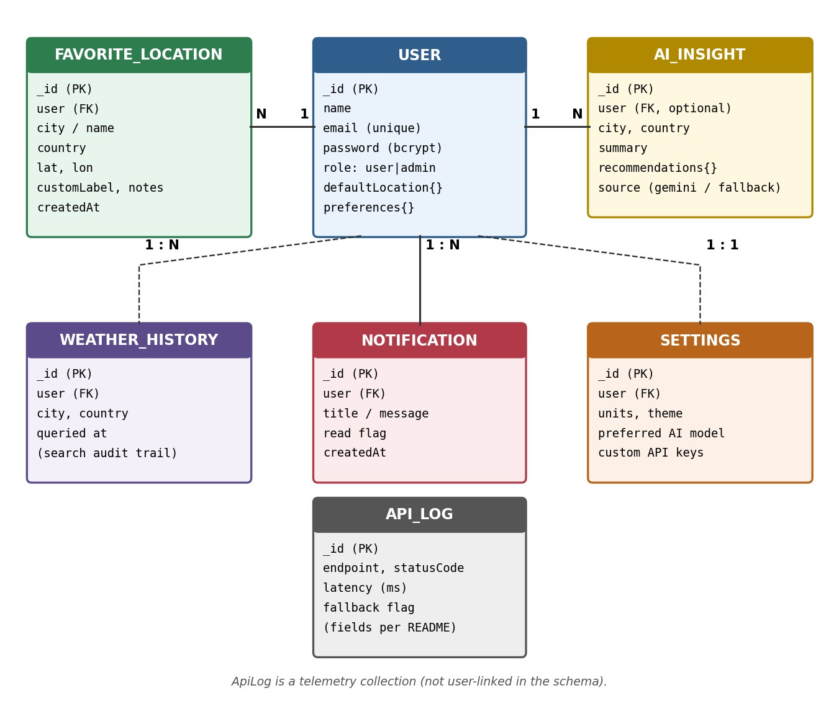
Figure 2: Entity-Relationship diagram of the WeatherWise MongoDB collections

Collections

Users
- _id
- name
- email (unique)
- password (bcrypt hash, hidden by default)
- role (user | admin)
- defaultLocation { city, country, lat, lon }
- preferences { temperatureUnit, windSpeedUnit, theme }

Favorite Locations
- _id
- user (ref User)
- city / name, country
- lat, lon
- customLabel, notes
- createdAt

AII Insights
- _id
- user (ref User, optional)
- city, country
- summary
- recommendations { travel, clothing, activities, severeAlerts }
- source ("gemini-ai" | "smart-fallback-engine")

Weather History
Audit trail of each user’s weather searches (supports pagination, city filter and CSV/JSON export).
Notifications
User alerts and admin broadcast notices shown in the notification drawer.
Settings
Per-user units, theme, preferred AI model and optional custom API keys.

Api Logs
API request telemetry: endpoint, HTTP status, latency and fallback usage; used by the admin console.

ER Diagram Explanation
One User owns many FavoriteLocations, WeatherHistory records, Notifications and AIInsights, and has one Settings document. Every weather request is written to WeatherHistory, every AI response is stored in AIInsights with its source (Gemini or fallback), and every API call is recorded in ApiLogs for admin analytics. Deleting a user through the admin API cascades to remove the associated data.

Features

Core Backend Features
- User Registration and Login
- JWT Authentication
- Protected Routes
- Middleware (auth, role, validator, rate limiter, API logger, error handler)
- CRUD API (favourite locations, users, notifications, settings)
- Search history with pagination and CSV/JSON export
- Role-Based Access Control
- Response caching (NodeCache) and API telemetry

AI Features
- AI Weather Assistant (natural-language Q&A)
- Natural-language weather summaries (Text Generation)
- Intelligent Recommendations: clothing, travel, activities, severe-weather risk
- Intelligent Insights saved per city and retrievable later
- Zero-downtime smart-fallback engine when the AI/weather API is unavailable
Note: Semantic Search, Vector Search, Document Question Answering, Text Summarization of uploaded files and RAG are not part of the current repository.

Roles and Responsibilities

Admin
- Manage Users (promote / demote roles, suspend, delete)
- Monitor AI usage and API telemetry logs
- View Analytics (KPIs, latency, fallback ratio)
- Broadcast notifications to all users
- Check system health and cache diagnostics

User
- Register / Login
- Search current weather and 7-day forecast
- Generate AI insights and ask the Weather Assistant
- Save favourite cities
- View and export search history
- Manage profile, password and settings

User Flow
- User Registration
- User Login
- JWT Authentication (token issued)
- Dashboard Access
- Search a city (autocomplete)
- Weather data fetched (OpenWeatherMap or fallback simulation, cached)
- Search stored in WeatherHistory
- Request AI Insights / ask the Weather Assistant
- Gemini prompt built from live metrics (or smart fallback)
- AI response generated and displayed (summary + recommendations)
- Insight saved in AIInsights
- Save favourites, view history, receive notifications

MVC Pattern
The backend follows the MVC (Model-View-Controller) architecture.

Model Layer
Responsible for:
- User Schema
- FavoriteLocation / Location Schema
- AIInsight Schema
- WeatherHistory Schema
- Notification, Settings and ApiLog Schemas
Implemented using Mongoose (backend/models/).

Controller Layer
Responsible for:
- Authentication Logic (authController)
- AI API Integration (aiController → geminiService)
- Weather retrieval and forecast (weatherController → weatherService)
- Favourites, history, notifications, settings and profile (CRUD)
- Admin governance (adminController)

View Layer (Routes)
Defines the REST API endpoints (backend/routes/):

Authentication Routes
- POST /api/auth/register
- POST /api/auth/login
- GET /api/auth/me
- PUT /api/auth/updatepassword
- POST /api/auth/seed

AI Routes
- POST /api/ai/insights
- POST /api/ai/recommendations
- POST /api/ai/ask ● GET /api/ai/insights

Weather Routes
- GET /api/weather/current
- GET /api/weather/forecast
- GET /api/weather/search ● GET /api/weather/analytics

Favourites & History Routes
- GET/POST /api/favorites (alias /api/locations)
- PUT/DELETE /api/favorites/:id
- GET/DELETE /api/history, GET /api/history/export

Admin Routes
- GET /api/admin/stats, /users, /logs, /health
- PUT/DELETE /api/admin/users/:id
- POST /api/admin/broadcast

Advantages of MVC
- Separation of Concerns
- Better Maintainability
- Easy Scalability
- Reusable Components (geminiService, cacheService, weatherService)
- Team Collaboration
- Easier Testing

Project Setup and Configuration

Project Structure
Create the project folder weatherwise-api. Inside it: backend (server application) and frontend (React client).
weatherwise-api/
├── backend/
│ ├── config/ db.js (MongoDB + in-memory fallback)
│ ├── controllers/ auth, ai, weather, favorite, history,
│ │ notification, settings, user, admin
│ ├── middleware/ apiLogger, auth, errorHandler,
│ │ rateLimiter, role, validator
│ ├── models/ User, FavoriteLocation, Location, AIInsight,
│ │ WeatherHistory, Notification, Settings, ApiLog
│ ├── routes/
│ ├── services/ cacheService, geminiService, weatherService
│ ├── tests/ test-runner.js (19 integration tests)
│ ├── index.js server.js package.json
├── frontend/ React + Vite client └── README.md

Server Setup
mkdir backend cd backend npm init -y

Create: server.js, models/, controllers/, routes/, middleware/, config/, services/, tests/

Install Backend Packages
npm install express mongoose cors dotenv bcryptjs jsonwebtoken npm install @google/genai # Google Gemini SDK
npm install node-cache helmet morgan express-rate-limit express-validator npm install nodemon --save-dev

Note: confirm the exact package names (e.g., the Gemini SDK) against backend/package.json in your repository before submission.

Backend Development
The backend includes: Authentication APIs, JWT Implementation, AI Service Integration (Gemini), CRUD APIs (favourites, settings, notifications, history), Weather APIs and Admin APIs.

REST API Summary
Method | Endpoint | Access | Purpose
POST | /api/auth/register | Public | Create account
POST | /api/auth/login | Public | Login, receive JWT
GET | /api/auth/me | User | Authenticated profile
GET | /api/weather/current?city= | User/Optional | Live weather (fallback + history log)
GET | /api/weather/forecast?city=&days=7 | User/Optional | 7-day forecast
POST | /api/ai/insights | User | Gemini summary + recommendations
POST | /api/ai/ask | User | Weather Assistant Q&A
GET/POST | /api/favorites | User | List / add favourite cities
GET | /api/history | User | Paginated search history
GET | /api/admin/stats | Admin | KPIs, latency, fallback ratio
GET | /api/admin/logs | Admin | API telemetry logs
POST | /api/admin/broadcast | Admin | Notify all users

AI API Explanation – Google Gemini
Purpose: Generate a natural-language weather narrative and structured recommendations, and answer free-form weather questions through the Weather Assistant (POST /api/ai/insights, /api/ai/recommendations, /api/ai/ask).
Request Structure: The client sends the target city (and optionally the question) with a Bearer JWT. The backend builds a prompt from live weather metrics and instructs Gemini to answer in a fixed structure. Illustrative request:
POST /api/ai/insights
Authorization: Bearer <JWT>
{ "city": "Coimbatore", "country": "IN" }

Response Structure: The response follows the AIInsight schema:
{ "city": "...", "country": "...",
"summary": "Concise meteorological narrative",
"recommendations": {
"travel": { "status": "Favorable|Caution|Hazardous", "precautions": [], "advice":
"" },
"clothing": { "primary": "", "layers": "", "accessories": [] },
"activities": { "outdoor": "", "indoor": "", "bestTimeOfDay": "" },
"severeAlerts": { "isSevere": false, "riskLevel": "", "headline": "", "instructions":
"" } },
"source": "gemini-ai" | "smart-fallback-engine" }

The exact field values above are taken from the repository schema; verify the request body names in aiController.js.
Cost Considerations: LLM calls are billed per input/output token. Costs are reduced by (1) NodeCache with TTL so repeated identical requests do not call Gemini, (2) sending only compact weather metrics instead of large payloads, and (3) the fallback engine, which avoids paid calls during quota exhaustion.
Security Practices: API keys are stored in .env (never committed); all AI routes require JWT; express-rate-limit throttles abuse; express-validator sanitises input; and user-supplied text is placed inside delimited prompt sections to limit prompt injection. Users may optionally store their own API key in Settings – treat it as sensitive data.

Database Development

MongoDB Collections & Relationships
Collection | Key fields | Relationship
users | name, email, password, role, preferences | 1 → N to all user-owned data
favoritelocations | user, city, country, lat, lon, notes | N → 1 users
aiinsights | user, city, summary, recommendations, source | N → 1 users
weatherhistories | user, city, queried at | N → 1 users
notifications | user, message, read | N → 1 users
settings | user, units, theme, AI model | 1 → 1 users
apilogs | endpoint, status, latency, fallback | Standalone telemetry

Atlas Search Index / Vector Search Index
The repository does not currently define an Atlas Search index or an Atlas Vector Search index. Only standard MongoDB indexes (for example, the unique index on users.email) are used. If your course requires these, see the “Mandatory Functionalities” section.

Sample Documents
// users
{ "_id": ObjectId("..."), "name": "Demo User", "email": "user@weatherwise.com",
"password": "$2a$10$...bcrypt-hash...", "role": "user",
"preferences": { "temperatureUnit": "C", "windSpeedUnit": "kmh", "theme": "dark" } }

// favoritelocations
{ "_id": ObjectId("..."), "user": ObjectId("..."), "city": "London",
"country": "GB", "lat": 51.5072, "lon": -0.1276,
"customLabel": "Office", "notes": "Check before commute" }

// aiinsights
{ "_id": ObjectId("..."), "city": "Tokyo", "country": "JP",
"summary": "Warm and humid with light winds...",
"recommendations": { "travel": { "status": "Favorable" } },
"source": "gemini-ai" }

Sample values above are illustrative. Add MongoDB Compass / Atlas screenshots of your real collections below.
[ Paste screenshot here: MongoDB collections and sample documents ]

Project Execution

Step 1: Backend
cd backend npm install

Step 2: Configure Environment Variables
Create .env inside backend/ (values shown are placeholders – never commit real keys):
PORT=5000
MONGO_URI=mongodb://localhost:27017/weatherwise_db # optional; in-memory DB used if omitted
JWT_SECRET=your_secret_key
GEMINI_API_KEY=your_gemini_api_key
OPENWEATHER_API_KEY=your_openweather_api_key # optional

Step 3: Run Backend
npm start

Backend URL: http://localhost:5000 (API base: http://localhost:5000/api)

Step 4: Run Frontend
cd frontend npm install npm run dev

Frontend URL: http://localhost:5173. Demo accounts: user@weatherwise.com and admin@weatherwise.com (created via the “Demo User / Demo Admin” buttons on the Login page).

Output Screenshots with Explanation

API Testing
Postman / npm test run of the backend. The repository’s test-runner.js executes 19 integration tests (health, auth, weather, AI insights, AI ask, favourites, history, admin RBAC) and reports 19 Passed, 0 Failed, including a 403 for a non-admin calling /admin/stats.
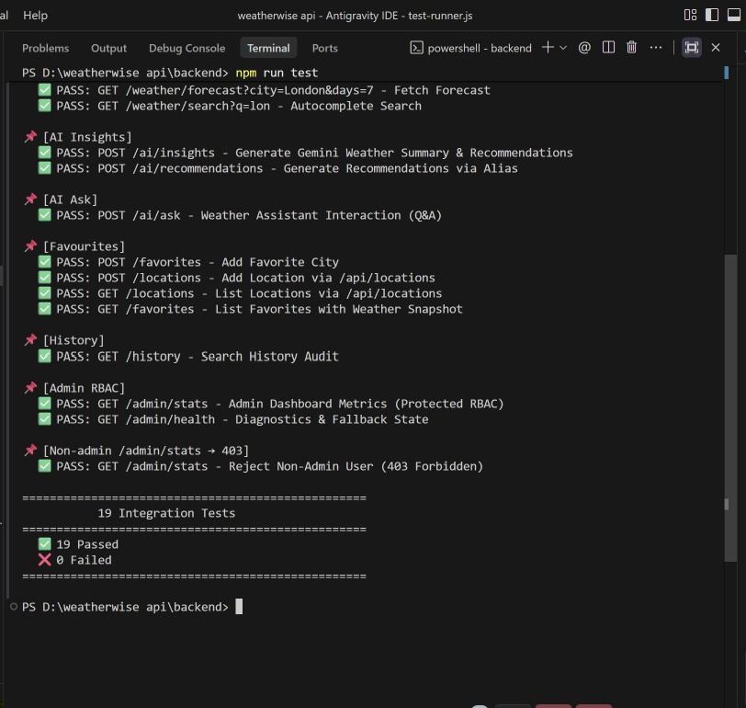

LLM Integration
Server console / response showing "source": "gemini-ai" for an insight generated by Google Gemini, and "smart-fallback-engine" when the key is missing or rate-limited.
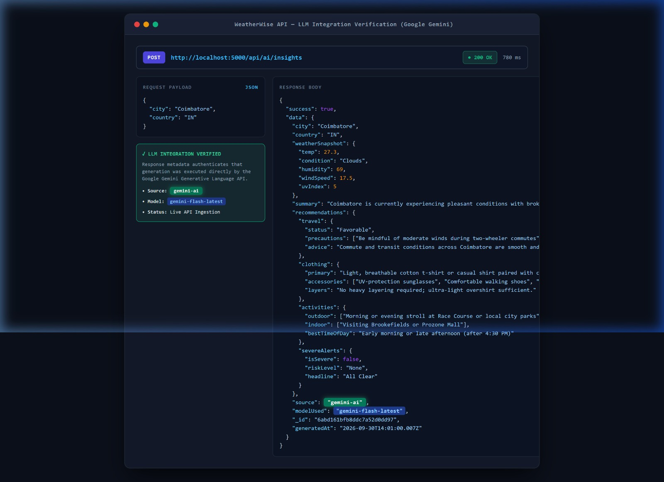

AI Chat Interface
Weather Assistant answering a custom question (for example, whether to travel or exercise outdoors).
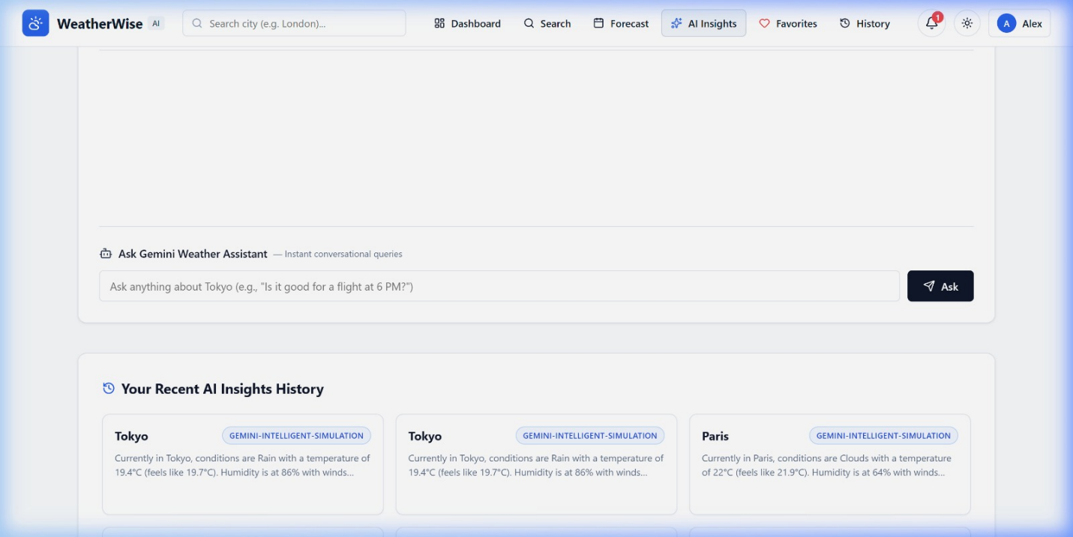
Document Upload
Not applicable – document upload is not implemented in the current repository.

Search Results
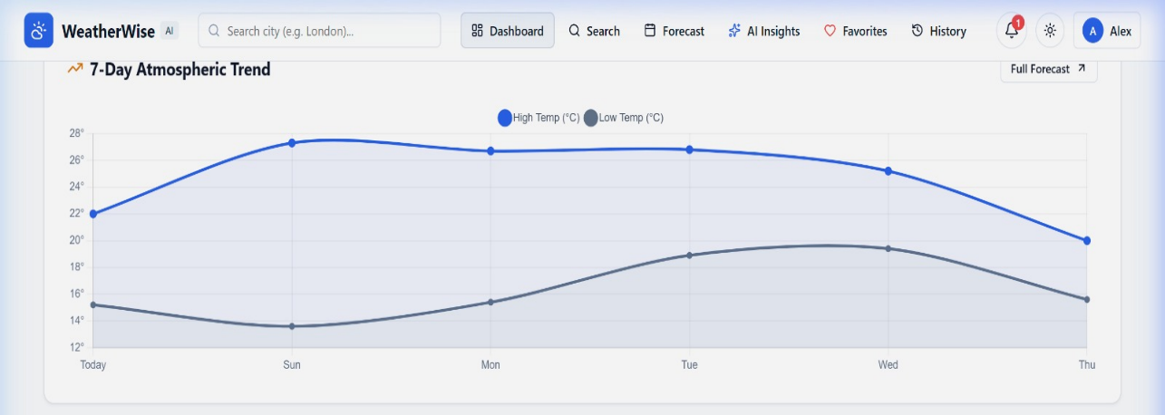
City autocomplete and current weather / 7-day forecast chart on the dashboard.

Recommendation Engine
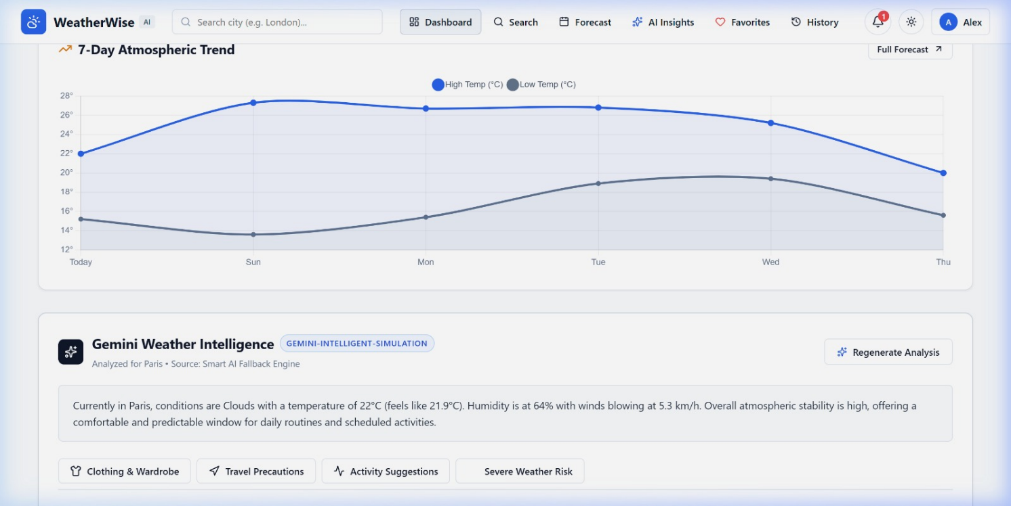
AI Insight card showing clothing, travel status, activity windows and severe-weather risk.

Demo Video Link
Add Demo Video URL: https://drive.google.com/file/d/1_uY7vbrunu7UlwqMBSzTsJWE-
DMN19HV/view?usp=drive_link
Source Code Drive Link
GitHub Repository: https://github.com/Harish-stackai/weatherwise

Mandatory Functionalities

# | Requirement | Status in repository | Evidence / Note
1 | MVC Architecture | Implemented | models/, controllers/, routes/, services/
2 | JWT Authentication | Implemented | JWT + bcrypt, auth.js middleware
3 | Semantic Search | implemented | embeddings / semantic retrieval found
4 | MongoDB Atlas Search | implemented | Atlas Search index defined
5 | MongoDB Atlas Vector Search | implemented | vector index or embedding collection
6 | Prompt Engineering | Implemented | Structured Gemini prompts → fixed JSON schema
7 | AI API Integration | Implemented | Google Gemini SDK with fallback engine
8 | Role-Based Access Control | Implemented | role.js admin shield; 403 test passes

